TechMPower Use of AI and Large Language Models (LLMs) in the R33 Phase

Overview
This appendix describes approved and ethically appropriate uses of artificial intelligence (AI) and large language models (LLMs) to support the R33 phase of the TechMPower study. AI tools will be used exclusively for analytic augmentation, data quality assurance, and implementation feedback, and will not be used for clinical decision-making, participant eligibility determination, or custody-related actions.

Alignment With R33 Aims
AI/LLM methods are integrated across all three R33 aims to improve analytic efficiency, rigor, and transparency while maintaining strict human-subjects protections.

R33 Aim 1: Effectiveness
AI tools will support data quality monitoring of CASI surveys, normalization of open-ended responses, and exploratory pattern detection across stepped-wedge time periods. These methods complement, but do not replace, pre-specified generalized linear mixed models.

R33 Aim 2: Implementation Science
LLMs will be used to assist in qualitative coding of stakeholder interviews and to synthesize implementation metrics mapped to PRISM and RE-AIM domains. Outputs are used for site-level feedback and collaborative quality improvement, not individual evaluation.

R33 Aim 3: Cost-Effectiveness and Sustainability
AI-assisted classification of cost components and scenario modeling will improve efficiency of economic analyses and support sustainability planning. All analyses rely on de-identified and aggregated cost data.

Human Subjects Protections
All AI-assisted analyses will use de-identified or limited datasets obtained under existing informed consent. No AI outputs will influence participant compensation, access to services, parole decisions, or correctional status. All results will be reviewed by trained research staff prior to dissemination.

Figure A1. Conceptual Map of AI/LLM Use Across R33 Aims
This figure illustrates how AI and LLM tools support data quality, implementation feedback, and analytic synthesis across R33 Aims 1–3 while maintaining human oversight and ethical safeguards.

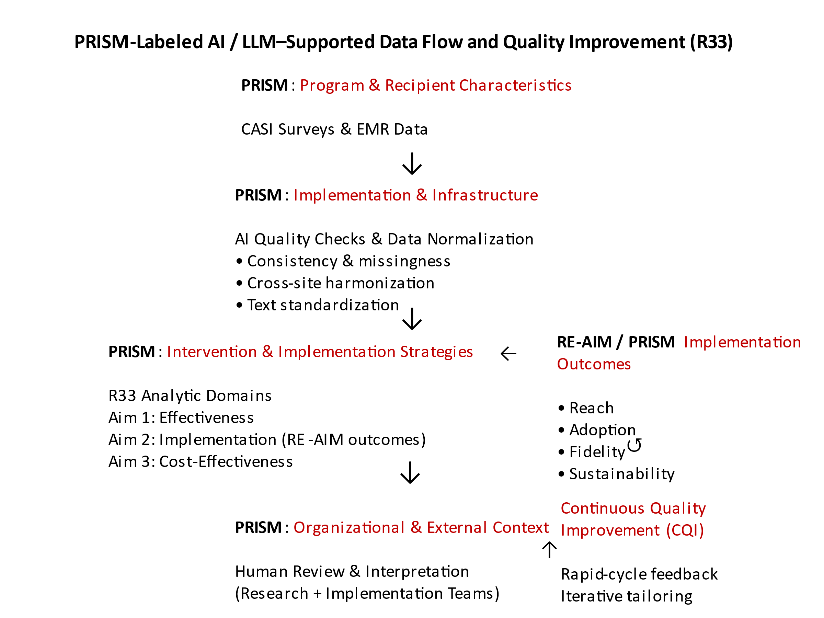

1. Cross-Cutting Principles for AI/LLM Use in R33
Positioning:
AI/LLMs are used as decision-support, analytic augmentation, and fidelity-monitoring tools, not as autonomous decision-makers, clinicians, or risk stratifiers affecting custody, care access, or parole.
Guardrails (important for IRB + NIH):
- No AI model outputs are used to determine eligibility, benefits, or sanctions.
- All AI-assisted outputs are reviewed by trained research staff.
- Models operate on de-identified or limited datasets only.
- AI is never used for surveillance, prediction of criminal behavior, or individual risk scoring in jail settings.

2. R33 Aim-Specific Opportunities

Aim 1 – Effectiveness (HIV testing, PrEP/PEP/ART, MOUD, OEND)
R33|Aim 1: Test effectiveness of TechMPower on: (1) HIV testing (including self-testing) and results receipt (status knowledge); (2) biomedical HIV prevention/treatment use (PEP/PrEP/ART); (3) SUD prevention/treatment use (OEND/MOUD), in 6 jails with 1200 people using a cluster stepped wedge design (3 steps); assess how socio-demographics may influence impacts. (Effectiveness)
AI/LLM Applications
- Adaptive Survey Quality Monitoring
  - Use LLMs to flag inconsistent, incomplete, or illogical CASI responses (e.g., HIV test uptake reported without test exposure).
  - Supports data quality without altering participant responses.
- Natural Language Normalization of Open-Ended Responses
  - Jail and community surveys include open-text fields (barriers, facilitators, service experiences).
  - LLMs can standardize language into coded domains (e.g., stigma, logistics, trust, health literacy) for mixed-methods integration.
- Temporal Pattern Detection in Stepped-Wedge Data
  - ML-assisted time-series analysis to detect nonlinear uptake patterns across steps (e.g., delayed MOUD initiation post-implementation).
  - Complements GLMMs already specified; does not replace confirmatory inference.
Data Sources
- CASI surveys (baseline, 3-month, 6-month)
- De-identified EMR service utilization (HIV tests, MOUD, OEND)
- Aggregate jail-level EBP delivery counts
Human Subjects Implications
- Uses existing consented data only
- No new data collection
- Outputs reported at group or site level only

Aim 2 – Implementation Science (PRISM / RE-AIM)
R33|Aim 2: Assess how select PRISM external and internal contextual factors impact TechMPower reach, effectiveness, adoption, implementation and maintenance/sustainability outcomes using mixed methods. (Implementation science)
AI/LLM Applications
- Automated Coding of Qualitative Interviews
  - LLM-assisted first-pass coding of stakeholder interviews (coalition, jail staff, CBOs).
  - Codes mapped directly to PRISM domains (external context, internal context, implementation infrastructure).
- Cross-Site Implementation Pattern Discovery
  - Unsupervised clustering to identify implementation phenotypes (e.g., “high leadership buy-in / low IT capacity” sites).
  - Used for hypothesis generation and tailoring TA—not evaluation of individuals.
- Implementation Fidelity Dashboards
  - AI-supported synthesis of:
    - Training completion logs
    - Service delivery records
    - Coalition engagement metrics
  - Provides near-real-time feedback to implementation teams, consistent with collaborative quality improvement described in protocol.
Data Sources
- Stakeholder surveys
- Qualitative interview transcripts
- Training attendance records
- Coalition and implementation team logs
Human Subjects Implications
- Stakeholders are not prisoners
- Outputs used for process improvement, not personnel evaluation
- De-identified reporting at site or role level only
TechMPower R33 Human Subjects 0…

Aim 3 – Cost-Effectiveness & Sustainability
R33|Aim 3: Calculate cost-effectiveness of TechMPower on primary outcomes, and implications for feasibility of program expansion and sustainability. (Cost effectiveness)

AI/LLM Applications
- Automated Cost Component Classification
  - LLMs categorize narrative cost inputs (staff time logs, resource descriptions) into standardized cost buckets.
  - Reduces manual abstraction burden.
- Scenario Modeling for Sustainability
  - ML-assisted simulations of:
    - Scale-up scenarios
    - Staffing substitutions
    - Telehealth vs in-person mixes
  - Inputs into ICER sensitivity analyses (does not replace economic modeling).
- Narrative Translation for Policymakers
  - LLMs generate plain-language summaries of cost-effectiveness findings for counties, coalitions, and funders.
Data Sources
- Staff time tracking
- Resource utilization
- Participant-level service uptake (de-identified)
- County cost data
Human Subjects Implications
- No new participant data
- Uses aggregated and de-identified cost data only

Data Type | AI Function | Value Added | Risk Level
CASI survey data | Consistency checks, missingness detection | Improves data integrity | Minimal
EMR abstraction | Automated validation & normalization | Reduces abstraction error | Minimal
Qualitative interviews | LLM-assisted coding | Speeds mixed-methods analysis | Low
Implementation logs | Pattern detection | Improves fidelity monitoring | Minimal
Cost data | Classification & simulation | Improves economic rigor | Minimal

